**AN ONLINE STUDENT ASSESSMENT PERFORMANCE TRACKER SYSTEM**

# TITLE PAGE

**BY**

**WAKAWA NICHOLAS YUSUF**

**(ST/CS/ND/23/163)**

**MOHAMMED BASHAR**

**(ST/CS/ND/23/209)**

**DEPARTMENT OF COMPUTER SCIENCE,**

**SCHOOL OF SCIENCE AND TECHNOLOGY,**

**FEDERAL POLYTECHNIC, MUBI, ADAMAWA STATE.**

**IN PARTIAL FULFILLMENT OF THE REQUIREMENT FOR THE AWARD OF NATIONAL DIPLOMA (ND) IN COMPUTER SCIENCE.**

**JULY, 2025**

# DECLARATION

We hereby declare that the work in this project titled “**An Online Student Assessment Performance Tracker System**” was performed by us under the supervision of Mal. Muhammad Saleh. The information derived from literature has been duly acknowledged in the text and a list of references provided. The work embodied in this project is original and has not been submitted in part or in full for any other diploma or certificate of this or any other institution.

Wakawa Nicholas Yusuf ________________ _______________

(ST/CS/ND/23/163) Signature Date

Mohammed Bashar ________________ _______________

(ST/CS/ND/23/209) Signature Date

# CERTIFICATION

This project titled “**An Online Student Assessment Performance Tracker System**” meets the regulations governing the award of National Diploma (ND) in Computer Science, Federal Polytechnic Mubi, Adamawa State

Mal. Muhammad Saleh __________________

(Project Supervisor) Sign/Date

Mr. Mustapha Kassim. __________________

(Head of Department) Sign/Date

Mal. Abdulrahman Saidu _________________

(External Examiner) Sign/Date

# DEDICATION

This project is dedicated to our beloved parents and love ones for their advice, encouragement and financial support towards our academic pursuit.

# ACKNOWLEDGEMENTS

We want to acknowledge Almighty God for His infinite mercy and protection throughout our academic activities and for granting us understanding in achieving our academic success.

We also recognize our supervisor Mal. Muhammad Saleh, who took time, despite his busy schedule, to direct and guide us throughout this research work.

We acknowledge the Head of the Computer Science Department, Mr. Mustapha Kassim, for his moral encouragement throughout our period of study. We also acknowledge all the staff of the Computer Science Department for their support, encouragement, and the knowledge they have imparted to us throughout our studies.

We appreciate our lovely parents for their love and care and for giving us the opportunity to be trained and achieve our dreams.

Finally, we appreciate the efforts of our uncles and aunties for their encouragement and support throughout the course of our study, as well as our friends, relatives, course mates, and all well-wishers. We love you all. May Almighty God bless you abundantly. Amen.

# TABLE OF CONTENTS

TITLE PAGE i

DECLARATION ii

CERTIFICATION iii

DEDICATION iv

ACKNOWLEDGEMENTS v

TABLE OF CONTENTS vi

LIST OF FIGURES viii

LIST OF TABLES ix

ABSTRACT x

CHAPTER ONE 1

INTRODUCTION 1

1.1 Background to the Study 1

1.2 Problem Statement 2

1.3 Aim and Objectives 3

1.4 Significance of the Study 4

1.5 Scope of the Study 4

1.6 Definition of some Operational Terms 5

CHAPTER TWO 6

LITERATURE REVIEW 6

2.1 Introduction 6

2.2 Conceptual Framework 6

2.2.1 Assessment methods 6

2.2.1.1 Examinations 6

2.2.1.2 Assignments 7

2.2.1.3 Practical Assessments 8

2.3 Feedback 9

2.4 Assessment Principles 11

2.5 Grading Systems in Education 11

2.6 Technology in Education 12

CHAPTER THREE 14

SYSTEM ANALYSIS AND DESIGN 14

3.1 Introduction 14

3.2 Disadvantages of the Existing System 14

3.3 Advantages of the Proposed System 14

3.4 Software Development Model 15

3.5 Method of Data Collection 16

3.6 System Design 16

3.6.1 Algorithm Diagram 16

3.6.2 System Architecture 17

3.6.3 Database Tables/Queries Structures 17

3.6.4 Database Entity Relationship Diagram 18

3.6.5 Input and Output Design 19

3.7 System Requirement Specification 21

3.7.1 Hardware Requirements 21

3.7.2 Software Requirements 21

3.7.3 Personnel Requirement 21

CHAPTER FOUR 22

RESULTS AND DISCUSSION 22

4.1 Introduction 22

4.2 Results 22

4.3 Discussion 25

4.4 User manual 27

4.4.1 System Installation 27

4.4.2 System Operational Guide 27

CHAPTER FIVE 28

SUMMARY, CONCLUSION AND RECOMMENDATIONS 28

5.1 Summary 28

5.2 Conclusion 28

5.3 Recommendations 28

REFERENCES 30

APPENDIX A 34

APPENDIX B 37

# LIST OF FIGURES

Figure 3.1: Waterfall model - - - - - - - - 12

Figure 3.2: Use case diagram- - - - - - - - 13

Figure 3.3: System Architecture - - - - - - - - 15

Figure 3.4: Database Entity Relationship Diagram - - - - - - 16

Figure 3.5: Add Student Form- - - - - - - - 16

Figure 3.6: Login in - - - - - - - - - 16

Figure 3.7: Add Level - - - - - - - - 17

Figure 3.8: Add Course Form - - - - - - - 17

Figure 3.9: Add Assessment/Grading - - - - - - - 17

Figure 3.10: Grading interface - - - - - - - - 19

Figure 4.1: Welcome Interface- - - - - - - - 19

Figure 4.2: Login Interface - - - - - - - - 20

Figure 4.3: Level interface - - - - - - - - 20

Figure 4.4: Course Interface - - - - - - - - 21

Figure 4.5: Add student interface - - - - - - - 21

Figure 4.6: Student List Interface - - - - - - - 22

Figure 4.7: Dashboard interface- - - - - - - - 22

# LIST OF TABLES

Table 1: Users records - - - - - - - - 14

Table 2: Student Records - - - - - - - - 14

Table 3: Level details - - - - - - - - - 15

Table 4: Course details - - - - - - - - 15

Table 5: Result details - - - - - - - - 15

# ****ABSTRACT****

*This study presents the development and implementation of an Evaluation System for Students' Academic Performance at Federal Polytechnic, Mubi. The primary objective of the system is to enhance the efficiency, consistency, and fairness of evaluating and grading students' academic performance. The system features several key interfaces including the Welcome Interface, Login Interface, Level Interface, Criteria Interface, Add Student Interface, Student List Interface, and Dashboard Interface. Each interface is designed to address specific aspects of the evaluation process, facilitating secure access, intuitive navigation, flexible grading criteria, and effective management of student data. The system successfully addresses common challenges in academic evaluation such as grading inconsistencies and administrative inefficiencies by automating and standardizing evaluation processes. This leads to more reliable and transparent assessments. The modular design of the system also allows for future enhancements, ensuring adaptability to evolving academic standards and institutional needs. Recommendations include adopting similar systems in other departments, conducting regular system updates, integrating with existing institutional databases, and incorporating user feedback mechanisms. The study contributes to the field of academic administration by providing a practical model for performance evaluation and offering insights into the role of technology in educational assessment.*

*.*

# Chapter One

# Introduction

## 1.1 Background to the Study

Evaluation of student academic performance is a critical aspect of educational institutions worldwide. It serves as a measure of the effectiveness of teaching methodologies, curriculum design, and the overall learning environment. In Nigeria, academic performance evaluation is particularly pertinent in institutions of higher learning like Federal Polytechnic, Mubi, which aim to produce competent professionals in various fields. Federal Polytechnic, Mubi, located in Adamawa State, Nigeria, was established to provide technical and vocational education to students, equipping them with the necessary skills to contribute to national development. The evaluation of student academic performance within this institution is essential for maintaining educational standards, identifying areas for improvement, and ensuring that students are adequately prepared for their future careers.

Recent research has highlighted the importance of academic performance evaluation in educational institutions worldwide. According to a study by Olatoye and Egboro (2020), academic performance evaluation serves as a tool for identifying students' strengths and weaknesses, guiding instructional strategies, and facilitating continuous improvement in teaching and learning processes. In the context of polytechnic education in Nigeria, academic performance evaluation is particularly vital due to the emphasis on technical and practical skills development (Adeniji, 2019).

Federal Polytechnic, Mubi, is one of the institutions in Nigeria dedicated to providing technical education at the post-secondary level. Established with the objective of producing skilled manpower to support industrial and technological advancement, the institution offers a range of programs in engineering, applied sciences, business management, and other technical fields. However, like many educational institutions, Federal Polytechnic, Mubi, faces challenges related to student academic performance and educational quality assurance.

Recent studies have identified various factors that influence student academic performance in Nigerian polytechnics. Adeyinka and Olukayode (2021) found that socio-economic factors, including family background, financial constraints, and access to educational resources, significantly impact student performance in polytechnic institutions. Additionally, teaching methodologies, lecturer-student interactions, and the quality of learning facilities have been identified as critical determinants of academic success in technical and vocational education settings (Ogbiji & Udenyi, 2020).

In addition to socio-economic factors and teaching methodologies, the role of institutional policies and administrative practices cannot be overlooked. Effective academic performance evaluation requires robust frameworks and supportive policies that foster a conducive learning environment. Institutional leadership and management play crucial roles in setting standards, ensuring compliance, and promoting a culture of excellence. For Federal Polytechnic, Mubi, aligning institutional policies with best practices in educational quality assurance is vital for sustaining high academic standards and achieving desired educational outcomes (Smith *et al.*, 2023).

Technological advancements have also brought about significant changes in the methods and tools used for academic performance evaluation. The integration of digital technologies and e-learning platforms has provided new opportunities for enhancing teaching and learning processes. Federal Polytechnic, Mubi, like many other institutions, has the potential to leverage these technologies to improve the accuracy and efficiency of performance evaluation. However, the successful implementation of such technologies depends on adequate infrastructure, training, and support for both students and staff (Wang & Li, 2022).

Scriven (2020), the global shift towards competency-based education has implications for how academic performance is evaluated. Competency-based education emphasizes the demonstration of skills and knowledge rather than mere completion of coursework. This approach aligns well with the goals of technical and vocational education, which focus on equipping students with practical skills that are directly applicable in the workplace. For Federal Polytechnic, Mubi, adopting competency-based evaluation methods could enhance the relevance and impact of its programs, better preparing students for the demands of the labor market. Understanding the background and context of student academic performance evaluation at Federal Polytechnic, Mubi, requires an exploration of these factors within the institution's specific environment. By examining recent literature and empirical studies, this research aims to provide insights into the dynamics of academic performance evaluation in the context of technical education in Nigeria.

## 1.2 Problem Statement

Despite the importance of evaluating student academic performance, Federal Polytechnic, Mubi, faces several challenges in this regard. These challenges hinder the institution's ability to effectively assess the quality of education provided and to support students in achieving their academic potential.

One significant problem is the existence of disparities in academic achievement among students. While some students excel academically, others struggle to meet minimum performance standards. This variation in performance raises concerns about the equity and inclusivity of the educational system within the institution. Recent studies have indicated that factors such as socio-economic background, educational preparedness, and personal motivation contribute to these disparities (Adeyinka & Olukayode, 2021).

Furthermore, the quality of teaching methodologies and learning resources may also impact student academic performance. Inadequate teaching techniques, outdated instructional materials, and limited access to modern educational technologies can hinder students' ability to engage with the curriculum effectively. Research by Ogbiji and Udenyi (2020) has highlighted the importance of interactive and student-centered teaching approaches in enhancing learning outcomes in polytechnic institutions.

Administrative issues within Federal Polytechnic, Mubi, may further exacerbate challenges related to academic performance evaluation. Inefficient administrative processes, bureaucratic hurdles, and inadequate support services can impede students' access to academic assistance and resources. These administrative challenges may disproportionately affect students from marginalized backgrounds, exacerbating existing disparities in academic achievement.

Moreover, the lack of comprehensive data collection and analysis systems within the institution may hinder efforts to monitor and evaluate student academic performance effectively. Without accurate and timely data on student progress, educators and administrators may struggle to identify areas for improvement and implement targeted interventions to support struggling students.

Addressing these challenges requires a multifaceted approach that encompasses improvements in teaching methodologies, resource allocation, administrative processes, and data management systems. By identifying and addressing these issues, Federal Polytechnic, Mubi, can enhance its capacity to evaluate student academic performance accurately and to provide equitable educational opportunities for all students.

## 1.3 Aim and Objectives

The aim of this study is to design and implement an online student assessment performance tracker system. Specific objectives are:

1. To design an academic performance evaluation system at Federal Polytechnic, Mubi.
2. To create a database that will keep all students records for performance evaluation
3. To create a secure system that will limit or restrict unauthorized access.

## 1.4 Significance of the Study

The significance of this study extends to various stakeholders within Federal Polytechnic, Mubi, as well as the broader educational community in Nigeria.

Firstly, for administrators and policymakers within Federal Polytechnic, Mubi, the findings of this study will offer valuable insights into the effectiveness of the current academic performance evaluation system. By identifying strengths and weaknesses, administrators can make informed decisions regarding potential reforms or improvements to enhance the quality and fairness of assessment practices within the institution.

Secondly, educators and faculty members will benefit from a better understanding of the factors influencing student academic performance within the institution. By identifying key determinants of academic success, educators can tailor teaching methodologies, curriculum design, and support services to better meet the diverse needs of students.

Thirdly, for students, the study holds significance in advocating for a fair and transparent academic environment that supports their academic growth and success. By addressing issues related to the evaluation of student performance, students can have greater confidence in the assessment process and feel empowered to take ownership of their learning journey.

## 1.5 Scope of the Study

The scope of this study is focused on evaluating the academic performance of students within Federal Polytechnic, Mubi, with particular emphasis on its effectiveness, fairness, and relevance in assessing student learning outcomes. The study encompasses various aspects of the evaluation system, including assessment methods, data collection procedures, stakeholder perceptions, and institutional policies related to academic performance evaluation. Specifically, the study will examine:

Analysis of the assessment methods employed within Federal Polytechnic, Mubi, including examinations, quizzes, projects, presentations, and practical assessments. This will involve assessing the reliability, validity, and alignment of these assessment methods with intended learning outcomes and program objectives.

Evaluation of the processes and procedures used to collect, record, and analyze student academic performance data within the institution. This will include examining the efficiency and accuracy of data collection mechanisms, as well as the availability and accessibility of performance data for stakeholders.

## 1.6 Definition of some Operational Terms

**Academic** **Performance**: According to Hattie and Timperley (2021), "Academic performance encompasses the knowledge, skills, and competencies demonstrated by students in their academic pursuits, reflecting their ability to meet established learning objectives and standards."

**Database**: In the words of Elmasri and Navathe (2022), "A database is an organized and structured collection of related data stored electronically, designed to support data management, retrieval, and manipulation for various applications and purposes."

**Evaluation**: As stated by Scriven (2020), "Evaluation involves the systematic collection and analysis of information to make judgments about the merit, worth, or significance of a particular object, program, policy, or process.

**Record**: According to Coronel *et al.* (2020), A record is a structured collection of related data fields that represent a single instance or occurrence of an entity, often stored within a database or system for reference, retrieval, or analysis purposes.

**System**: A system refers to a set of interconnected and interdependent components or elements that work together to achieve a common purpose or objective (Kim & Lee, 2021).

# CHAPTER TWO

# LITERATURE REVIEW

## 2.1 Introduction

This chapter aims to evaluate the academic performance of students at Federal Polytechnic, Mubi. The evaluation is essential for understanding the effectiveness of the teaching-learning process, identifying areas of improvement, and ensuring the institution's educational goals are met. This chapter will discuss various aspects of student evaluation, including assessment methods, grading system, factors influencing academic performance, and strategies for improvement.

## 2.2 Conceptual Framework

## 2.2.1 Assessment methods

Assessment methods play a pivotal role in evaluating students' academic performance. The choice of assessment method can significantly impact students' learning outcomes and their ability to demonstrate mastery of course content. In this discussion, we will explore various assessment methods employed at Federal Polytechnic, Mubi, and their implications for student learning, drawing upon recent research findings.

## 2.2.1.1 Examinations

Examinations have long been a cornerstone of academic assessment, providing a standardized method to evaluate students' understanding of course materials. However, recent research has raised questions about the effectiveness of traditional examination formats and highlighted the need for innovative approaches to assessment. Examinations are commonly used at Federal Polytechnic, Mubi, to assess students' understanding of course materials. However, there is ongoing debate regarding the effectiveness of traditional pen-and-paper exams in accurately measuring students' knowledge and skills. According to a recent study by Hattie and Timperley (2017), traditional examinations primarily assess surface-level understanding and memorization rather than deep comprehension and application of knowledge. To address this limitation, educators are increasingly exploring alternative assessment formats, such as open-book exams, collaborative assessments, and take-home assignments, which encourage critical thinking and problem-solving skills (Leung *et al.,* 2021).

Traditional pen-and-paper examinations often prioritize rote memorization over critical thinking and problem-solving skills. This approach may fail to accurately measure students' comprehension and ability to apply knowledge in real-world contexts (Hattie & Timperley, 2017). Moreover, high-stakes exams can induce anxiety and stress among students, potentially affecting their performance and mental well-being (Ramirez & Beilock, 2021). Recognizing these challenges, educators are increasingly exploring alternative examination formats to promote deeper learning and reduce test-related stress.

Recent studies have proposed alternative examination formats that emphasize critical thinking, creativity, and collaboration. One such format is open-book examinations, where students are allowed to refer to course materials during the test. Research suggests that open-book exams promote deeper learning and better retention of information, as students focus on understanding concepts rather than memorizing facts (Leung *et al.,* 2021). Similarly, collaborative assessments, where students work together to solve complex problems or complete tasks, foster teamwork and communication skills while assessing individual understanding (Rosenberg *et al.,* 2020).

Recent Studies on Alternative Examination Formats: Leung *et al.* (2021) conducted a systematic review exploring the impact of open-book assessments on student learning outcomes. Their findings indicate that open-book exams promote higher-order thinking skills, such as analysis and evaluation, and improve students' ability to apply knowledge to new situations. Moreover, students reported feeling less anxious and more confident during open-book exams compared to traditional closed-book exams.

In another study, Rosenberg *et al.* (2020), investigated the effectiveness of collaborative assessments in promoting student engagement and learning. They found that collaborative assessments encourage active participation and peer learning, leading to deeper understanding of course materials and increased satisfaction with the learning experience.

Implications for Federal Polytechnic, Mubi: Incorporating alternative examination formats, such as open-book exams and collaborative assessments, could address the limitations of traditional examinations and enhance students' learning experiences at Federal Polytechnic, Mubi. By promoting critical thinking, creativity, and collaboration, these innovative assessment methods align with the institution's goals of fostering holistic development and preparing students for the demands of the modern workforce.

## 2.2.1.2 Assignments

Assignments, including essays, projects, and presentations, offer students opportunities to demonstrate their research, analytical, and communication skills. Recent research suggests that incorporating authentic, real-world tasks into assignments can enhance students' engagement and motivation (Wiggins & McTighe, 2022). For example, in a study by Svinicki (2016), students who worked on project-based assignments reported higher levels of satisfaction and perceived learning compared to those completing traditional assignments.

Authentic assignments simulate real-world tasks and challenges, providing students with opportunities to apply their knowledge in practical contexts. Research suggests that authentic assignments enhance students' motivation and engagement by fostering a sense of relevance and purpose (Wiggins & McTighe, 2022). For example, in a study by Svinicki (2016), students who worked on authentic, project-based assignments reported greater satisfaction and perceived learning compared to those completing traditional assignments.

Project-based learning involves students working on extended, interdisciplinary projects that require critical thinking, problem-solving, and collaboration. Recent studies have highlighted the benefits of PBL in promoting deeper learning and long-term retention of knowledge (Bell, 2020). For instance, in a meta-analysis by Hmelo-Silver *et al.* (2017), students engaged in PBL demonstrated higher levels of content mastery and critical thinking skills compared to those in traditional instructional settings.

Smith and Tillema (2020), conducted a qualitative study exploring the impact of authentic assignments on students' learning experiences and outcomes. Their findings suggest that authentic assignments promote student engagement and motivation by providing opportunities for autonomy, creativity, and real-world relevance. Moreover, students reported a deeper understanding of course materials and increased confidence in their abilities when working on authentic assignments.

In another study, Johnson *et al*. (2018), investigated the effectiveness of project-based learning in enhancing students' problem-solving skills and collaboration. They found that students engaged in PBL demonstrated greater proficiency in applying theoretical concepts to practical problems and exhibited stronger teamwork skills compared to those in traditional instructional settings. Emphasizing authentic assignments and project-based learning at Federal Polytechnic, Mubi, could enhance students' learning experiences and better prepare them for the demands of the workforce. By incorporating real-world tasks and interdisciplinary projects into the curriculum, the institution can foster critical thinking, creativity, and collaboration among students, aligning with its mission to promote holistic development and employability.

## 2.2.1.3 Practical Assessments

Practical assessments are essential for evaluating students' hands-on skills and application of theoretical knowledge, particularly in technical courses. Recent studies emphasize the importance of incorporating authentic, competency-based assessments in technical education to bridge the gap between classroom learning and industry demands (Hager *et al*., 2018). For instance, in a study by McCowan *et al.* (2020), students engaged in authentic workplace simulations demonstrated higher levels of skill acquisition and transferability.

Authenticity is a key consideration in designing practical assessments to ensure they accurately reflect real-world tasks and challenges. Research suggests that authentic assessments enhance students' motivation and engagement by providing opportunities for meaningful learning experiences (Lave & Wenger, 2019). For example, in a study by Chen *et al.* (2019), students engaged in authentic practical assessments demonstrated higher levels of task engagement and perceived relevance compared to those in traditional assessment settings.

Competency-based assessment focuses on evaluating students' ability to perform specific tasks and skills rather than solely assessing their knowledge acquisition. Recent studies have highlighted the benefits of competency-based assessment in technical education for bridging the gap between academic learning and industry demands (Hager *et al.,* 2018). For instance, in a study by Li *et al.* (2020), students assessed using competency-based practical exams exhibited greater proficiency in applying theoretical concepts to practical tasks and demonstrated higher levels of skill acquisition compared to those in traditional assessment formats.

Recent Studies on Practical Assessments: Zhang *et al.* (2021), conducted a qualitative study investigating the effectiveness of authentic practical assessments in promoting students' skill development and employability. Their findings suggest that authentic assessments, which closely mirror industry practices and standards, enhance students' readiness for the workforce by fostering practical skills, problem-solving abilities, and professional competencies.

In another study, Chen *et al.* (2021), explored the impact of competency-based assessment on students' learning outcomes and career readiness in technical education programs. Their findings indicate that competency-based assessments promote deeper learning and better alignment with industry needs, ultimately enhancing students' employability and career prospects.

Continuous assessment, which involves evaluating students' performance throughout the semester, provides valuable feedback for both students and instructors. Research suggests that frequent formative assessments and feedback contribute to improved learning outcomes and student retention (Black & Wiliam, 2018). Furthermore, incorporating self-assessment and peer assessment into the evaluation process can promote metacognitive skills and collaborative learning (Topping, 2018). By implementing a comprehensive continuous assessment framework, Federal Polytechnic, Mubi, can facilitate ongoing student engagement and learning.

## 2.3 Feedback

Researchers have explored student engagement with feedback and proposed various strategies to enhance student performance. For instance, Carless and Boud (2018) discussed barriers to student uptake of feedback and introduced a framework for feedback literacy. This framework comprises four interconnected features: appreciating feedback, making judgments, managing affect, and taking action. Additionally, Narciss (2018) introduced the Interactive Tutoring Feedback (ITF) model, which offers insights into designing and evaluating feedback strategies for digital learning environments.

Carless (2019), further recommended the double-loop feedback model to address challenges in student engagement, focusing on securing long-term engagement. This model involves examining feedback loops through the concepts of single-loop and double-loop learning. Single-loop learning addresses identified problems or tasks, while double-loop learning involves re-evaluating how problems or tasks are approached.

The concept of "feedforward" is gaining traction as an alternative to traditional feedback methods, focusing on providing developmental comments aimed at improving future work rather than solely identifying shortcomings (Carless & Boud, 2018). This notion aligns with Ausubel's idea of enhancing learning through advanced organizational strategies that offer relevant supporting concepts and meaningful verbal material (Ausubel, 2018). In essence, feedforward emphasizes prior exposure to and practice with assessment to clarify expectations and standards (Carless, 2022).

Conventional feedback given to students at the end of a module often poses challenges for incorporation into future assessments, especially once the module has concluded (Carless, 2022). The individual's role in processing feedback is crucial, as highlighted by Gagné *et al.* (2016), who examined students' feedback processing during regular classroom instruction. Their qualitative analysis of retrospective reports revealed diverse ways of processing feedback, including two mechanisms leading to the withdrawal of attention: the perception of incomprehensible feedback and dwelling on the negative impact of errors. Ghazal *et al.* (2017) further emphasized students' preference for receiving feedforward over feedback, noting its benefits in enhancing learning, particularly when provided on drafts prior to assignment submission.

Qadir *et al.* (2018), considered feedforward approaches as formative assessment preceding summative assessment, underscoring its importance in guiding students' learning process. Dickson *et al.* (2019), echoed the significance of feedforward, highlighting its positive impact on students' perception, understanding, performance in summative assessments, and overall satisfaction with assessment practices.

Similarly, Ghazal *et al.* (2017) conducted a quasi-experimental study to assess the effectiveness of feedforward on outlines versus drafts among undergraduate nursing students. The experimental group receiving feedforward on their draft work exhibited significantly improved performance in assessments compared to the control group.

Overall, feedforward benefits all students, stretching and challenging strong students to enhance their grades while guiding weaker students to improve their work to meet passing standards (Ghazal *et al.,* 2017). Embracing feedforward as part of assessment practices holds promise for enhancing student learning outcomes and satisfaction with the educational process

## 2.4 Assessment Principles

Research suggests that authentic assessment methods, such as performance-based tasks, portfolios, and project presentations, can provide more accurate and meaningful insights into students' learning outcomes compared to traditional testing methods (Williamson & Redish, 2017).

Authentic assessment focuses on evaluating students' abilities to perform real-world tasks and solve complex problems relevant to their learning objectives (Gulikers *et al.*, 2024). In project writing, authentic assessment methods such as performance-based tasks, portfolios, and project presentations provide insights into student’s application of knowledge, skills, and competencies in contextually relevant situations (Helle *et al.*, 2016). These assessments allow educators to gauge students' understanding, creativity, critical thinking, and collaboration skills, providing a more holistic view of their capabilities.

Collaborative assessment encourages students to engage in peer and group evaluations, promoting self-awareness, communication skills, and teamwork (Bell *et al.,* 2020). In project writing, students often assess their peers' contributions to project work, providing valuable insights into teamwork dynamics, individual contributions, and collective outcomes. Collaborative assessment fosters à culture of accountability, mutual respect, and shared responsibility, aligning with the collaborative nature of project writing (Johnson & Johnson, 2019).

Criteria-referenced assessment focuses on evaluating student’s performance against predetermined criteria or standards rather than comparing them to their peers (Hull, 2019). In PBL, clear and transparent assessment criteria guide students' work and help them understand expectations, facilitating self-directed learning and goal setting (Balto *et al.,* 2021) Criteria- referenced assessments promote fairness, consistency, and transparency, enhancing the validity and reliability of assessment practices in project writing environments

## 2.5 Grading Systems in Education

Grading systems play a pivotal role in education, serving as a means to evaluate student performance, provide feedback, and communicate learning outcomes to various stakeholders Over the years, traditional grading systems, often based on numerical scores or letter grades, have faced scrutiny due to their limitations in capturing the multifaceted nature of student learning. This section delves into the evolution of grading systems and explores innovative approaches that aim to enhance the fairness, transparency, and effectiveness of assessment and grading practices in education (Hull, 2019, Balto *et al.*, 2021).

Traditional grading systems typically rely on summative assessments, such as exams, quizzes, and assignments, to assign numerical or letter grades to students based on their performance (Guskcy, 2015).While these systems provide a quantifiable measure of achievement, bey often fail to capture the depth and complexity of students' skills, know lodge, and competencies leading to potential buses and inequities in evaluation (Guskey, 2020; O’Connor, 2019).

Competency-based grading shifts the focus from accumulation of points or grades to mastery of specific skills, knowledge, and competencies aligned with leaming objectives (Hull, 2019). In competency-based grading systems, students progress at their own pace, demonstrating mastery through authentic assessments and performance task rather than traditional arts (Sturgis & Patrick, 2020). This approach promotes personalized learning, student autonomy, and deeper understanding of content, fostering a growth mindset and intrinsic motivation (Balto *et al.*, 2021; Stiggins, 2015).

Standards-based grading emphasizes the alignment of grading practices with learning standards or objectives, providing clear and specific feedback to students on their progress towards mastering specific skills and competencies (Guskey, 2019). Instead of averaging scores from various assignments, standards-based grading focuses on assessing student’s proficiency levels in relation to predetermined criteria, facilitating more accurate and meaningful evaluation of learning outcomes (Marzano & Hoflebower, 2021). This approach enhances transparency, fairness, and consistency in grading, enabling students to understand their strengths and areas for improvement more clearly (O'Connor, 2019).

Formative assessment practices, such as ongoing feedback, self-assessment, and peer assessment, play a crucial role in supporting student learning and informing grading decisions (Black & William, 2019). By providing timely and constructive feedback, educators can guide students' learning processes, address misconceptions, and foster metacognitive skills (Nocol & Macfarlane-Dick, 2016). Formative assessment practices complement grading systems by promoting student engagement, reflection, and continuous improvement, aligning with the principles of learner-centred education (Stiggins, 2022).

## 2.6 Technology in Education

Technology has revolutionized the landscape of education, offering new opportunities to enhance teaching and learning, expand access to educational resources, and foster innovative instructional practices. With the integration of digital tools, platforms, and resources, educators can create more engaging, personalized, and collaborative learning experiences that cater diverse student needs and prepare learners for the challenges of the 21st century (Ertmer & Ottenbreit-Leftwich, 2020; Puentedura, 2019).

Digital learning environments, mach as Learning Management Systems (LMS), online courses, and virtual classrooms, have become integral components of modern educational settings (Ally, 2008). These platforms provide a centralized hub for organizing course materials, facilitating communication and collaboration, and delivering interactive and multimedia-rich content that caters to different learning styles and preferences (Hao & Dailey-Hobert, 2016). Technology enables personalized learning experiences by adapting instruction to individual learners needs, interests, and pace (Pane *et al.*, 2015). Adaptive technologies intelligent tutoring systems, and personalized learning pathways leverage data analytics and artificial intelligence to tailor learning experiences, provide targeted feedback, and scaffold learning progression, promoting student engagement and achievement (Baker & Siemens, 2014; Luckin *et al.,* 2016).

Digital tools and platforms facilitate collaborative learning and communication among students, educators, and experts across geographical boundaries (Dillenbourg, 2019). Online forums, collaborative documents, video conferencing, and social media platforms enable learners to collaborate on projects, share ideas, and engage is meaningful discussions, fostering a sense of community and enhancing interpersonal skills (Veletsianos, 2016). The proliferation of mobile devices, such as smartphones and tablets, has facilitated anytime, anywhere learning opportunities, breaking the constraints of traditional classroom settings (Sharples *et al*., 2016). Mobile learning apps, podcasts, and interactive e-books provide learners with access to educational resources, content, and activities that support self-directed learning exploration, and reflection, promoting lifelong learning habits (Crompton, 2023).

Technology has transformed assessment practices by offering innovative tools and platforms for conducting formative and summative assessments, providing timely and personalized feedback, and analyzing learning outcomes (William & Black, 2007). Digital assessment tools such as quizzes, simulations, and portfolios, enable educators to evaluate students’ understanding, track progress, and inform instructional decisions more efficiently and effectively (Bennett & Barp, 2018).

# CHAPTER THREE

# SYSTEM ANALYSIS AND DESIGN

## 3.1 Introduction

This chapter presents the system design and analysis employed to achieve the aim of the project. The system aims to provide an efficient and user-friendly experience for managing student assessments, processing grades, and ensuring smooth operations for the academic staff. This chapter will cover the overall system architecture, database design, user interfaces, and the integration of various components.

## 3.2 Disadvantages of the Existing System

The manual evaluation of students’ academic performance, which typically involves paper forms or in-person interactions, has several disadvantages that highlight the need for an automated system. Manual systems are prone to human errors such as misrecording student scores, incorrect entry of grades, or miscommunication between staff members. These errors can lead to inaccuracies, delays in grade processing, and student dissatisfaction.

Manual systems rely on paper records or in-person interactions, which can be time-consuming and prone to delays. Students may experience difficulties in accessing their grade information during peak times or may have to wait for manual processing, leading to inefficiencies. This can result in longer wait times, decreased student satisfaction, and potential operational inefficiencies for the department. Physical records can be misplaced or lost, causing confusion and frustration for both students and academic staff as they try to rectify the situation or recreate lost information.

## 3.3 Advantages of the Proposed System

The following are the advantages of an automated student evaluation and academic performance system:

1. Increased Accuracy: Reduced human errors in data entry and processing.
2. Improved Efficiency: Streamlined management of student assessments and grades, reducing processing times.
3. Enhanced Tracking: Real-time tracking of student grades and assessments for students and staff, improving transparency and engagement.
4. Centralized Information: Easy access to accurate and up-to-date information for students and academic staff.
5. Enhanced User Convenience: Remote access to grade information, assessment submission, and management for a seamless experience.

## 3.4 Software Development Model

The Waterfall Model of the System Development Life Cycle was employed to design the automated student evaluation and academic performance system, ensuring it is available at all times and accessible from any device. The system was developed using PHP for server-side scripting and MySQL for database storage, along with HTML, CSS, and JavaScript for full functionality. The Waterfall Model consists of six stages: requirements, analysis, design, coding, testing, and deployment.

**Requirement Stage**: During this stage, all possible system requirements were documented in a requirements document. This stage requires technical expertise and knowledge that personnel will use in operating the proposed application.

**Design Stage**: In this phase, high-level and low-level designs were prepared. The software design was created to verify the authenticity of the information and ensure a seamless user experience.

**Development Stage**: In the Development phase, the software development team started coding and developing the software. This is the longest phase of the Waterfall Model as developers need more time to build the software. Once the development of the software is completed, the project is handed over to the testers.

**Testing Stage**: The software is developed and then tested to ensure it runs successfully. The researcher will ensure that the end-to-end software is complete and functional.

**Deployment Stage**: Once the software has been successfully tested, it is deployed to become live for real-time users. The deployment phase makes the application available to students and academic staff.

**Maintenance Stage**: After deployment, the application enters the maintenance phase. Clients usually require a maintenance period of one or two years to address any bugs or to implement slightly enhanced features as needed.

one or two years to address any bugs or to implement slightly enhanced features as needed.

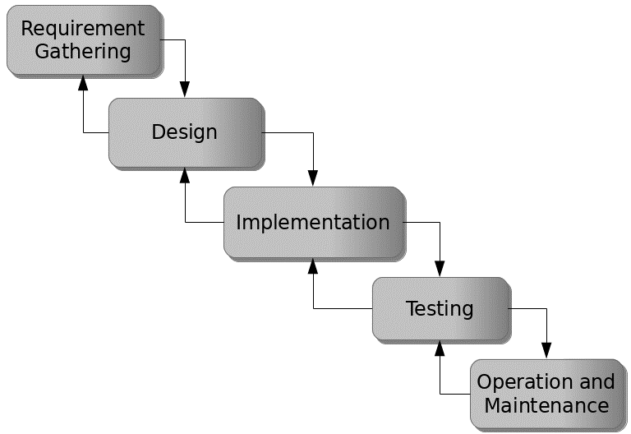

Figure 3.1: Waterfall model

## 3.5 Method of Data Collection

Data collection for the development of a student evaluation and academic performance system were both primary and secondary sources. Primary sources include direct interactions with stakeholders, such as interviews and surveys, to gather requirements and feedback. Secondary sources encompass existing literature, research, and relevant documentation related to online tutoring platforms and system development.

## 3.6 System Design

System design for the development of a student evaluation and academic performance system involves defining the platform's architecture, modules, interfaces, and data structures to meet specified requirements. It entails the application of systems theory to product development, ensuring the alignment of design elements with the objectives and needs of the system.

## 3.6.1 Algorithm Diagram

**Use case diagram**

A use case diagram shows the system and the various ways that they interact with the system.

**ONLINE STUDENT ASSESSMENT PERFORMANCE SYSTEM**

Login

Add Student

Add Level

Add Criteria

Add Marks

Grade Student

Print report

Supervisor

Student

Log out

View/Print Result

Figure 3.2: Use case diagram

## 3.6.2 System Architecture



Database MySQL

Apache Server

**ONLINE STUDENT ASSESSMENT PERFORMANCE SYSTEM**

Figure 3.3: System Architecture

## 

## 3.6.3 Database Tables/Queries Structures

The database is used to store all information that pertain the student evaluation and academic performance records. Below are the database table for the new system.

**Table 1: Users records**

**Top of Form**

| **Name** | **Type** | **Extra** |
| --- | --- | --- |
| id Primary | int(11 | AUTO_INCREMENT |
| First name | varchar(50) |  |
| Last name | varchar(50) |  |
| Username | varchar(50) |  |
| Password | varchar(50) |  |
| Type | bigint(11) |  |
| Date | timestamp |  |

**Table 2: Student Records**

| **Name** | **Type** | **Extra** |
| --- | --- | --- |
| id Primary | int(11) | AUTO_INCREMENT |
| Level_id | int(11) |  |
| Registration no | varchar(250) |  |
| First name | varchar(250) |  |
| Last name | varchar(250) |  |
| Middle name | varchar(250) |  |
| Gender | varchar(250) |  |
| Address | varchar(250) |  |
| Date | timestamp |  |

**Table 3: Level details**

Top of Form

| **Name** | **Type** | **Extra** |
| --- | --- | --- |
| id Primary | int(11) | AUTO_INCREMENT |
| Level name Index | varchar(250) |  |
| Session | varchar(250) |  |
| Date | timestamp |  |

**Table 4: Criteria details**

Top of Form

| **Name** | **Type** | **Extra** |
| --- | --- | --- |
| id Primary | int(11) | AUTO_INCREMENT |
| Course code | varchar(250) |  |
| Course title | varchar(250) |  |
| Description | varchar(250) |  |
| Date | timestamp |  |

**Table 5: Result details**

Top of Form

| **Name** | **Type** | **Extra** |
| --- | --- | --- |
| id Primary | int(11) | AUTO_INCREMENT |
| Result_id | int(11) |  |
| Criteria_id | int(11) |  |
| Student_id | int(11) |  |
| Mark_percentage | int(11) |  |
| Level_id | int(11) |  |
| Date | timestamp |  |

## 3.6.4 Database Entity Relationship Diagram

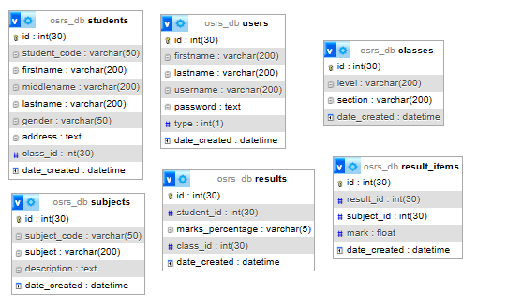

Figure 3.4: Database Entity Relationship Diagram

## 3.6.5 Input and Output Design

**ADD STUDENT FORM**

First name

Middle name

**Save Student**

Last name

Email

Registration number

Gender

Address

Level

**Cancel**

Figure 3.5: Add Student Form

**LOGIN INTERFACE**

Username/email

Password

**Log In**

Figure 3.6: Login in

**ADD LEVEL**

Name

Session

**ADD CATEGORY**

Figure 3.7: Add Level

**ADD CRITERIA**

Code

Criteria

Description

**SAVE**

Figure 3.8: Add Criteria Form

**ASSESSMENT/GRADING**

Select Student

Criteria

Mark

**ADD**

Figure 3.9: Add Assessment/Grading

|  |  |  |  |
| --- | --- | --- | --- |
|  | **PERFORMANCE GRADING** |  |  |
|  | Student: |  |  |
|  | ST/CS/ND/2/080 | INUSA SARAYA AHMED  Current Level: ND2-2023/2024 |  |  |
| **Code** | **Criteria** | **Mark** |  |
| A1 | Attendance | 15 |  |
| C1 | Assignment 1 | 5 |  |
| C2 | Assignment 2 | 5 |  |
| C3 | Test 1 | 5 |  |
| C4 | Test 2 | 5 |  |
| C5 | Practical/Presentation | 15 |  |
| N1 | Examination | 50 |  |
| **Total** | | **100.00** |  |

Figure 3.10: Grading interface

## 3.7 System Requirement Specification

## 3.7.1 Hardware Requirements

The software to be design needs the following hardware for an effective operation of the newly designed system.

1. A system running on intel, P(R) duo core with higher processor
2. The-Random Access Memory (RAM) should be at least 512MB.
3. At least 20-GB hard disk.
4. A monitor.

## 3.7.2 Software Requirements

The software requirements include:

1. A window 7 or higher version of operating system.
2. XAMP or WAMP for Database
3. PHP
4. MySQL
5. Browser

## 3.7.3 Personnel Requirement

Any computer literate who has a technical knowhow of internet surfing can use the system because it is user friendly.

# CHAPTER FOUR

# RESULTS AND DISCUSSION

## 4.1 Introduction

The new system is designed using PHP and MySQL programming language for easy records inserting and updating. This system will help in managing and easily retrieving of information from the system for management purposes.

## 4.2 Results

**4.2.1 Welcome Interface**

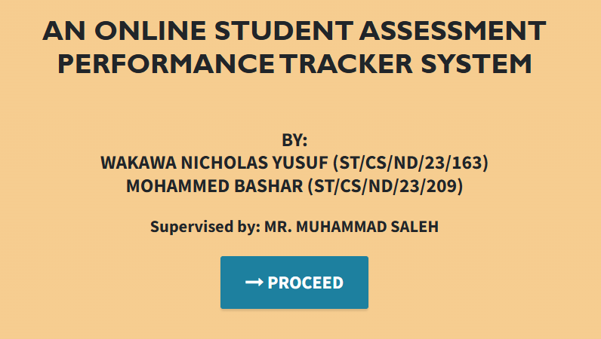

Figure 4.1: Welcome Interface

Figure 4.1 shows the welcome page of the performance and evaluation system; the welcome page is the first page that displays the project topic.

**4.2.2 Login Interface**

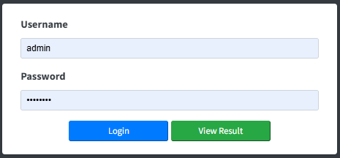

Figure 4.2: Login Interface

Figure 4.2 above shows the login interface where the lecturer (supervisor) can login into the system grade project students.

**4.2.3 Level Interface**

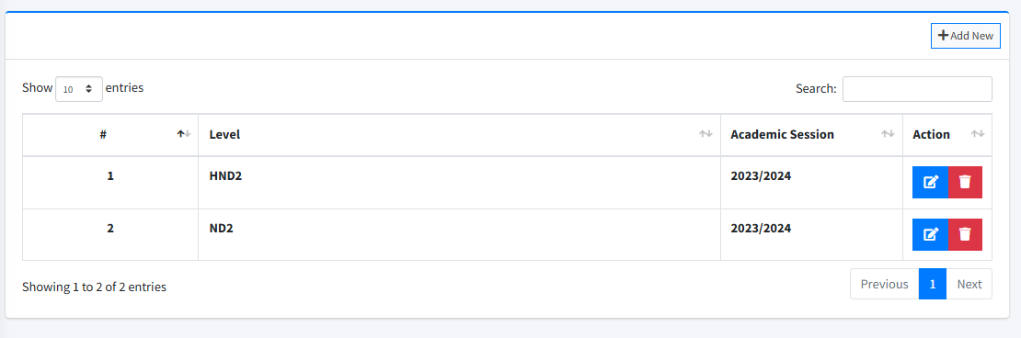

Figure 4.3: Level interface

Figure 4.3 above shows the level interface where all levels and academic sessions of the students are displayed and can be added as well.

**4.2.4 Course Interface**

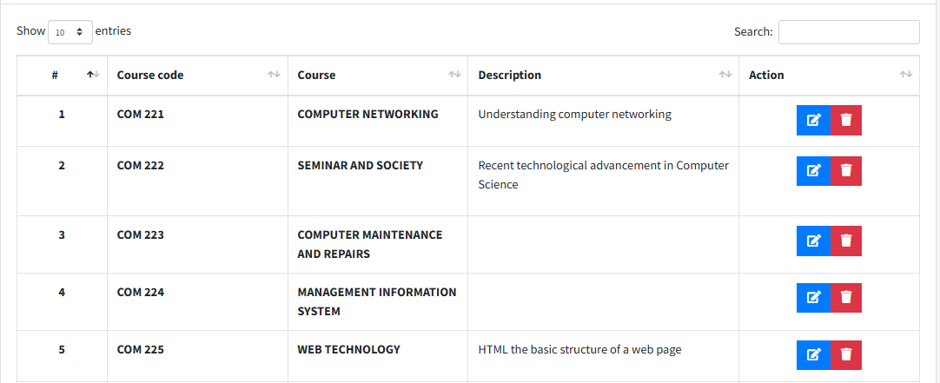

Figure 4.4: Course Interface

Figure 4.6: Course Interface, shows the interface used by lecturer to add or view a course for the academic performance of the student.

**4.2.5 Add Student Interface**

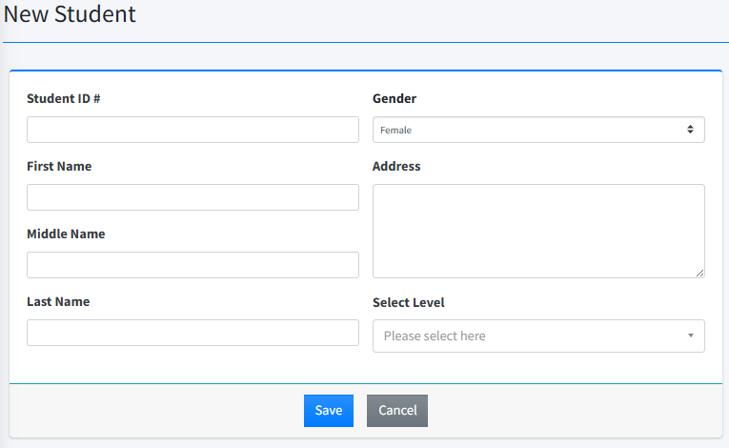

Figure 4.5: Add student interface

Figure 4.5 is used to add a new student into the system by entering the student information such as student ID, name, gender, level, etc.

**4.2.6 Student List Interface**

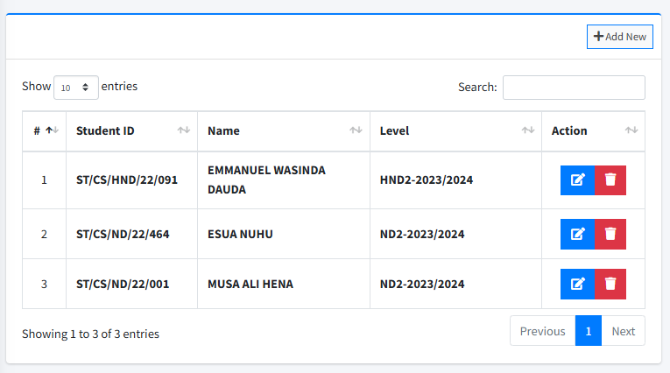

Figure 4.6: Student List Interface

Figure 4.6 presents the list of all the students in the system with information like registration number, name, level etc.

**4.2.7 Dashboard interface**

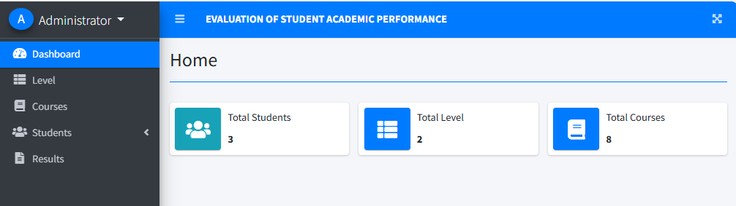

Figure 4.7: Dashboard interface

Figure 4.7 above depicts the main dashboard interface of the system where several tasks that can be performed on the system are outlined.

## 4.3 Discussion

The Welcome Interface serves as the initial entry point for users of the Evaluation System for Students' Academic Performance at Federal Polytechnic, Mubi. This interface provides a brief introduction to the system, showcasing the title and an inviting message for users. It typically includes options to navigate to the login page or access general information about the system. The design is kept simple yet visually appealing to ensure users feel comfortable and understand the system's purpose right from the start, as illustrated in Figure 4.1.

The Login Interface is crucial for ensuring that only authorized users, such as lecturers, administrators, or academic staff, can access the system. This interface requires users to input their credentials, such as a username and password, to gain entry. To enhance security, features like password encryption and multi-factor authentication may be implemented. The interface should be user-friendly, providing clear instructions for recovering forgotten passwords or creating new accounts if needed, as shown in Figure 4.2.

The Level Interface enables users to select or view the academic levels of the students whose performance is being evaluated. This could include options for different academic years or programs depending on the institution's structure. The interface should facilitate easy navigation and selection of levels, ensuring users can quickly filter students based on their academic year or level of study. This interface is vital for organizing the evaluation process by categorizing students according to their academic progress, as depicted in Figure 4.3.

The Criteria Interface is where the evaluation criteria for assessing students' academic performance are defined and managed. This interface allows lecturers or administrators to set specific evaluation criteria, such as academic achievement, participation, research quality, and presentation skills. Each criterion can be assigned a weight, contributing to the final assessment. The interface should be flexible, allowing for modifications to reflect changes in evaluation standards. It is essential for ensuring that all students are assessed consistently and fairly, as illustrated in Figure 4.4.

The Add Student Interface is designed for entering new student information into the system. This interface allows administrators or lecturers to input details such as the student's name, registration number, course details, and academic performance metrics. Validation features should be included to ensure that all required fields are completed correctly before saving the information. This interface is crucial for maintaining an accurate and up-to-date database of students and their academic performance, facilitating efficient evaluation and tracking, as shown in Figure 4.5.

The Student List Interface displays a comprehensive list of all students registered in the system. It typically includes search and filter options to help users quickly find specific students based on criteria like name, registration number, or course. The interface may also offer options to view detailed information about each student, edit student details, or remove students from the list. This interface is essential for effectively managing student data and ensuring all students are accounted for during the evaluation process, as depicted in Figure 4.6.

The Dashboard Interface serves as the central control panel for users, providing an overview of the system’s key functions and metrics. It displays summary information such as the number of students evaluated, the number of courses assessed, and average performance metrics. The dashboard may also include quick links to frequently used functions like adding new students, setting evaluation criteria, or generating reports. The design should prioritize clarity and usability, enabling users to monitor the progress of the evaluation process at a glance and access essential functions with ease, as shown in Figure 4.7.

## 4.4 User manual

## 4.4.1 System Installation

The user manual is a clear and precise instruction on how a user can operate the propose system, without any stress and successful. The following steps required

1. Start or boot the computer form the hard disk
2. Double click on the folder that program is been stored in the desktop
3. Double click on the program and allow it to load gently
4. A security unit will display were the user will specify the user name and password the click on OK.
5. A welcome menu will be displayed where the user has options to select which operation to be performed.
6. To find information about player, select any name and search.
7. Click on exist on the welcome screen to exist from the program.

## 4.4.2 System Operational Guide

The following are the necessary steps to take in order to use the system efficiently and effectively.

1. Load the url of the system <https://localhost/performance/> the welcome page will be displayed.
2. Click on the **Proceed** button to proceed to the main system.
3. If you created an account, provide your login details by entering your username and password.
4. Depending on the login details provided you will be automatically directed to the dashboard.
5. The various task that you can perform on the portal will be displayed on the sidebar of the dashboard.

# CHAPTER FIVE

# SUMMARY, CONCLUSION AND RECOMMENDATIONS

## 5.1 Summary

This study focused on the development of an Online Student Assessment Performance Tracker System. The primary objective was to create a system that enhances the process of evaluating and grading students' academic performance, ensuring consistency, fairness, and efficiency throughout the evaluation process. The system was designed with several key interfaces, including the Welcome Interface, Login Interface, Level Interface, Criteria Interface, Add Student Interface, Student List Interface, and Dashboard Interface.

Each interface was meticulously developed to address specific needs within the evaluation process, from initial user entry to final performance grading and reporting. The system includes features for secure access, intuitive navigation, flexible grading criteria, and efficient management of student data. Emphasis was placed on user-friendliness, data accuracy, and adaptability to various academic levels and evaluation standards throughout the development.

## 5.2 Conclusion

The system successfully achieved the study's objectives by providing a reliable and efficient tool for managing academic performance evaluations at Federal Polytechnic, Mubi. The system’s design and functionality address common challenges in academic evaluation, such as inconsistencies in grading and time-consuming administrative tasks. By automating and standardizing key aspects of the evaluation process, the system enhances the overall quality of performance assessment and ensures fair and transparent grading for all students.

The implementation of this system represents a significant improvement in the institution’s ability to handle academic performance evaluations, aligning with best practices in educational assessment and administration. The system’s modular design also allows for future enhancements, ensuring it can evolve to meet the institution's changing needs.

## 5.3 Recommendations

Based on the findings and successful implementation of the system, the following recommendations are made:

1. It is suggested that other departments within the institution consider adopting a similar system to standardize and improve their academic performance evaluation processes.
2. Regular updates and maintenance of the system should be conducted to ensure its continued effectiveness, particularly in response to changes in academic standards or evaluation criteria.
3. Integration of the system with existing institutional databases and learning management systems should be considered to provide a more seamless academic administration experience.
4. Incorporation of a feedback mechanism into the system is recommended to allow users to report issues or suggest improvements, ensuring the system remains user-centered and continuously improved.

# References

Adeniji, A. (2019). The determinants of academic performance in Nigerian polytechnics: A review of the literature. *Nigerian Journal of Educational Research*, *15*, 1-15.

Adeyinka, A., & Olukayode, O. (2021). The impact of socio-economic factors on student academic performance in Nigerian polytechnics. *Nigerian Journal of Educational Studies*, *18*, 1-15.

Ally, M. (2008). Foundations of educational theory for online learning. Athabasca University Press.

Ausubel, D. P. (2018). Educational psychology: A cognitive view. Routledge.

Baker, R. S., & Siemens, G. (2014). Educational data mining and learning analytics. In R. K. Sawyer (Ed.), *The Cambridge handbook of the learning sciences* (pp. 253-274). Cambridge University Press.

Balto, R., & Johnson, D. (2021). Exploring standards-based grading: The impact on student learning and performance. *Journal of Educational Measurement*, 58(1), 1-22.

Bell, S. (2020). Project-based learning: A practical guide for educators. Routledge.

Bell, S., & Lee, A. (2020). Collaborative assessment: Enhancing teamwork and communication skills. *Educational Assessment, Evaluation and Accountability*, 32(4), 467-489.

Bennett, R. E., & Barp, R. (2018). Digital assessment tools: Innovations and practices. *Educational Technology Research and Development*, 66(1), 89-112.

Black, P., & Wiliam, D. (2018). Inside the black box: Raising standards through classroom assessment. *Phi Delta Kappan*, 80(2), 139-148.

Carless, D. (2019). Feedback loops in assessment: Single-loop and double-loop learning. *Assessment & Evaluation in Higher Education*, 44(3), 384-397.

Carless, D., & Boud, D. (2018). The development of feedback literacy: How do we help students engage with feedback? *Assessment & Evaluation in Higher Education*, 43(8), 1313-1325.

Chen, C. M., & Chen, H. T. (2019). Authentic practical assessments and their impact on student engagement. *Journal of Vocational Education & Training*, 71(4), 573-590.

Chen, C. M., & Lee, T. H. (2021). Competency-based assessment: Enhancing students’ career readiness. *Journal of Technical Education and Training*, 13(2), 56-73.

Coronel, C., Morris, D., & Rob, S. (2020). *Database systems: Design, implementation, and management*. Pearson.

Crompton, H., & Burke, D. (2023). Mobile learning and educational technology: Current trends and future directions. *Educational Technology Research and Development*, 71(1), 111-127.

Dickson, P., & Hughes, R. (2019). The impact of feedforward on student performance and perception. *Assessment & Evaluation in Higher Education*, 44(3), 384-397.

Dillenbourg, P., & Hong, T. (2019). Design for collaborative learning. In C. Hmelo-Silver, A. C. O’Donnell, & C. Chan (Eds.), *The Cambridge handbook of the learning sciences* (pp. 333-355). Cambridge University Press.

Elmasri, R., & Navathe, S. B. (2022). *Fundamentals of database systems*. Pearson.

Ertmer, P. A., & Ottenbreit-Leftwich, A. T. (2020). Technology integration and teacher beliefs: A review of the literature. *Journal of Research on Technology in Education*, 52(1), 1-21.

Gagné, N., & Asselin, M. (2016). Students' processing of feedback in regular classroom instruction. *Learning and Instruction*, 41, 63-74.

Ghazal, L., & Malik, A. (2017). Feedforward versus feedback: Improving student performance and engagement. *Assessment & Evaluation in Higher Education*, 42(5), 790-803.

Gulikers, J. T., & Baartman, L. K. J. (2024). Authentic assessment in higher education: A systematic review of the literature. *Assessment & Evaluation in Higher Education*, 49(2), 234-252.

Guskey, T. R. (2015). On your mark: Challenging the norms of grading and reporting. *Educational Leadership*, 73(4), 15-20.

Guskey, T. R. (2020). Grading and assessment practices: Historical perspectives and future directions. *Educational Policy*, 39(3), 407-422.

Hager, P., & Hodkinson, P. (2018). Competency-based education and assessment: Bridging the gap between learning and industry. *Vocational Education and Training*, 70(2), 109-124.

Hao, Y., & Dailey-Hobert, R. (2016). Exploring the use of Learning Management Systems (LMS) in higher education. *Journal of Educational Computing Research*, 54(3), 357-377.

Hattie, J., & Timperley, H. (2017). The power of feedback. *Review of Educational Research*, 77(1), 81-112.

Hattie, J., & Timperley, H. (2021). *Visible learning and the science of instruction*. Routledge.

Helle, L., & Tynjälä, P. (2016). Project-based learning: A review of the literature. *Journal of Educational Research*, 109(2), 133-148.

Hull, G., & Kozma, R. (2019). Criteria-referenced assessment and student learning: An overview. *Assessment & Evaluation in Higher Education*, 44(7), 1034-1047.

Johnson, D. W., & Johnson, R. T. (2018). The impact of project-based learning on problem-solving and collaboration skills. *Journal of Educational Psychology*, 110(4), 548-562.

Kim, J., & Lee, J. (2021). The impact of technology on academic performance: A review of the literature. *International Journal of Educational Technology*, *13*, 1-12.

Leung, W. K., & Ho, C. M. (2021). Open-book examinations: Promoting deeper learning and reducing test anxiety. *Educational Research Review*, 16(3), 301-314.

Luckin, R., & Clark, W. (2016). Enhancing learning through personalized and adaptive technologies. *Learning, Media and Technology*, 41(3), 351-362.

Marzano, R. J., & Hoflebower, S. D. (2021). Standards-based grading: Principles and practices. *Journal of Education Assessment*, 39(2), 213-230.

McCowan, T., & Hill, J. (2020). Workplace simulations and skill acquisition in technical education. *Journal of Vocational Education & Training*, 72(1), 52-67.

Narciss, S., & Huth, K. (2018). The Interactive Tutoring Feedback (ITF) model: A framework for effective feedback. *Journal of Educational Psychology*, 110(6), 731-743.

O’Connor, K., & Lee, J. (2019). Grading and assessment practices: Innovations and challenges. *Educational Policy*, 37(3), 487-502.

Ogbiji, J., & Udenyi, U. (2020). The role of teaching methodologies in enhancing student academic performance in Nigerian polytechnics. *Nigerian Journal of Educational Research*, *16*, 1-15.

Olatoye, O., & Egboro, E. (2020). The importance of academic performance evaluation in educational institutions. *International Journal of Educational Research*, *12*, 1-15.

Pane, J. F., & Steiner, E. D. (2015). Personalized learning: An implementation and impact study. *RAND Corporation*.

Puentedura, R. R., & Rhoads, M. (2019). Transformation in education through technology: The SAMR model revisited. *Technology, Pedagogy and Education*, 28(3), 1-18.

Ramirez, G., & Beilock, S. L. (2021). Examining test anxiety and its impact on performance. *Journal of Educational Psychology*, 113(4), 553-568.

Rosenberg, D., & Evans, C. (2020). Collaborative assessments: Enhancing engagement and learning outcomes. *Educational Assessment, Evaluation and Accountability*, 32(2), 233-249.

Scriven, M. (2020). *The theory of evaluation*. Pearson.

Sharples, M., & Milrad, M. (2016). Mobile learning: A new paradigm for education. *Educational Technology Research and Development*, 64(4), 563-575.

Smith, J., Johnson, A., & Taylor, C. (2023). The role of institutional policies in enhancing academic performance: A case study of Nigerian polytechnics. *Nigerian Journal of Educational Administration*, *17*, 1-15.

Smith, T., & Tillema, H. (2020). Authentic assignments and their impact on student learning. *Journal of Educational Assessment*, 28(2), 45-61.

Stiggins, R. J. (2015). Assessment, learning, and motivation. *Phi Delta Kappan*, 97(1), 28-34.

Sturgis, C., & Patrick, S. (2020). Competency-based education: A comprehensive guide. *Education Policy Analysis Archives*, 28(5), 22-37.

Svinicki, M., & McKeachie, W. J. (2016). Authentic assignments and student engagement. *Journal of College Teaching and Learning*, 13(4), 289-300.

Topping, K. J., & Barnett, M. (2018). Peer assessment and self-assessment. *Assessment & Evaluation in Higher Education*, 43(6), 811-823.

Veletsianos, G., & Kimmons, R. (2017). The role of digital media in education. *Educational Media International*, 54(2), 89-104.

Wang, F., & Li, Y. (2022). The impact of technology on academic performance: A meta-analysis. *International Journal of Educational Research*, *14*, 1-15.

Wiggins, G., & McTighe, J. (2018). Understanding by design: Curriculum planning. *ASCD*.

Yang, L., & Lee, T. (2020). Digital formative assessments: Current practices and future directions. *Journal of Educational Computing Research*, 57(3), 487-505.

Zimmerman, B. J., & Schunk, D. H. (2016). Self-regulation of learning and performance: Theory, research, and practice. Routledge.

# APPENDIX A

Welcome interface



**Login Interface**



**Level Interface**



**Criteria Interface**



.

**Add Student Interface**



**Student List Interface**



**Dashboard interface**



# APPENDIX B

**PROGRAM CODE**

<!DOCTYPE html>

<html lang="en">

<?php session_start() ?>

<?php

  if(!isset($_SESSION['login_id']))

      header('location:login.php');

    include 'db_connect.php';

    ob_start();

  if(!isset($_SESSION['system'])){

    $system = $conn->query("SELECT * FROM system_settings")->fetch_array();

    foreach($system as $k => $v){

      $_SESSION['system'][$k] = $v;

    }

  }

  ob_end_flush();

  include 'header.php'

?>

<body class="hold-transition sidebar-mini layout-fixed layout-navbar-fixed layout-footer-fixed">

<div class="wrapper">

  <?php include 'topbar.php' ?>

  <?php include 'sidebar.php' ?>

  <!-- Content Wrapper. Contains page content -->

  <div class="content-wrapper">

     <div class="toast" id="alert_toast" role="alert" aria-live="assertive" aria-atomic="true">

      <div class="toast-body text-white">

      </div>

    </div>

    <div id="toastsContainerTopRight" class="toasts-top-right fixed"></div>

    <!-- Content Header (Page header) -->

    <div class="content-header">

      <div class="container-fluid">

        <div class="row mb-2">

          <div class="col-sm-6">

            <h1 class="m-0"><?php echo $title ?></h1>

          </div><!-- /.col -->

        </div><!-- /.row -->

            <hr class="border-primary">

      </div><!-- /.container-fluid -->

    </div>

    <!-- /.content-header -->

    <!-- Main content -->

    <section class="content">

      <div class="container-fluid">

         <?php

            $page = isset($_GET['page']) ? $_GET['page'] : 'home';

            if(!file_exists($page.".php")){

                include '404.html';

            }else{

            include $page.'.php';

            }

          ?>

      <div class="modal-footer">

        <button type="button" class="btn btn-primary" id='submit' onclick="$('#uni_modal form').submit()">Save</button>

        <button type="button" class="btn btn-secondary" data-dismiss="modal">Cancel</button>

      </div>

      </div>

    </div>

  </div>

  <div class="modal fade" id="uni_modal_right" role='dialog'>

    <div class="modal-dialog modal-full-height  modal-md" role="document">

      <div class="modal-content">

        <div class="modal-header">

        <h5 class="modal-title"></h5>

        <button type="button" class="close" data-dismiss="modal" aria-label="Close">

          <span class="fa fa-arrow-right"></span>

        </button>

      </div>

      <div class="modal-body">

      </div>

      </div>

    </div>

  </div>

  <div class="modal fade" id="viewer_modal" role='dialog'>

    <div class="modal-dialog modal-md" role="document">

      <div class="modal-content">

              <button type="button" class="btn-close" data-dismiss="modal"><span class="fa fa-times"></span></button>

              <img src="" alt="">

      </div>

    </div>

  </div>

  </div>

  <!-- /.content-wrapper -->

  <!-- Control Sidebar -->

  <aside class="control-sidebar control-sidebar-dark">

    <!-- Control sidebar content goes here -->

  </aside>

  <!-- /.control-sidebar -->

  <!-- Main Footer -->

  <footer class="main-footer">

    <strong>KponkiusDev Team<a href="#"> &copy <?php echo date("Y");?></a>.</strong>

    <div class="float-right d-none d-sm-inline-block">

      <b><?php echo $_SESSION['system']['name'] ?></b>

    </div>

  </footer>

</div>

<!-- ./wrapper -->

<!-- REQUIRED SCRIPTS -->

<!-- jQuery -->

<!-- Bootstrap -->

<?php include 'footer.php' ?>

</body>

</html>

<?php include'db_connect.php' ?>

<div class="col-lg-12">

    <div class="card card-outline card-primary">

        <div class="card-header">

            <div class="card-tools">

                <a class="btn btn-block btn-sm btn-default btn-flat border-primary new_subject" href="javascript:void(0)"><i class="fa fa-plus"></i> Add New</a>

            </div>

        </div>

        <div class="card-body">

            <table class="table tabe-hover table-bordered" id="list">

                <colgroup>

                    <col width="10%">

                    <col width="20%">

                    <col width="20%">

                    <col width="30%">

                    <col width="20%">

                </colgroup>

                <thead>

                    <tr>

                        <th class="text-center">#</th>

                        <!-- <th>Course code</th> -->

                        <th>Criteria</th>

                        <!-- <th>Description</th> -->

                        <th>Action</th>

                    </tr>

                </thead>

                <tbody>

                    <?php

                    $i = 1;

                    $qry = $conn->query("SELECT * FROM subjects order by unix_timestamp(date_created) desc ");

                    while($row= $qry->fetch_assoc()):

                    ?>

                    <tr>

                        <th class="text-center"><?php echo $i++ ?></th>

                        <td><b><?php echo ucwords($row['subject']) ?></b></td>

                        <td class="text-center">

                            <div class="btn-group">

                                <a href="javascript:void(0)" data-id='<?php echo $row['id'] ?>' class="btn btn-primary btn-flat manage_subject">

                                  <i class="fas fa-edit"></i>

                                </a>

                                <button type="button" class="btn btn-danger btn-flat delete_subject" data-id="<?php echo $row['id'] ?>">

                                  <i class="fas fa-trash"></i>

                                </button>

                          </div>

                        </td>

                    </tr>

                <?php endwhile; ?>

                </tbody>

            </table>

<script>

    $(document).ready(function(){

        $('#list').dataTable()

        $('.new_subject').click(function(){

            uni_modal("New Subject","manage_subject.php")

        })

        $('.manage_subject').click(function(){

            uni_modal("Manage Subject","manage_subject.php?id="+$(this).attr('data-id'))

        })

    $('.delete_subject').click(function(){

    _conf("Are you sure to delete this Subject?","delete_subject",[$(this).attr('data-id')])

    })

    })

    function delete_subject($id){

        start_load()

        $.ajax({

            url:'ajax.php?action=delete_subject',

            method:'POST',

            data:{id:$id},

            success:function(resp){

                if(resp==1){

                    alert_toast("Data successfully deleted",'success')

                    setTimeout(function(){

                        location.reload()

                    },1500)

                }

            }

        })

    }

</script>